I.T HUB , 5th floor(B-Block),Indra Nagar Colony

Dist : Khammam, State: Telangana, 507002.

CSS (Cascading Style Sheets) is the code that styles web content. *CSS basics* walks through what you need to get started. We'll answer questions like: How do I make text red? How do I make content display at a certain location in the (webpage) layout? How do I decorate my web page with background images and colors?

## [**What is CSS?**](https://developer.mozilla.org/en-US/docs/Learn/Getting_started_with_the_web/CSS_basics#what_is_css)

Like HTML, CSS is not a programming language. It's not a markup language either. **CSS is a style sheet language.** CSS is what you use to selectively style HTML elements. For example, this CSS selects paragraph text, setting the color to red:

p {

color: red;

}

Let's try it out! Using a text editor, paste the three lines of CSS (above) into a new file. Save the file as style.css in a directory named styles.

To make the code work, we still need to apply this CSS (above) to your HTML document. Otherwise, the styling won't change the appearance of the HTML.

Open your index.html file. Paste the following line in the head (between the [<head>](https://developer.mozilla.org/en-US/docs/Web/HTML/Element/head) and </head> tags):  
<link href="styles/style.css" rel="stylesheet">

Inline CSS

where the styles are defined inside the individual tags.

<DOCTYPE html>

<html>

<head>

<title>CSS Tutorial</title>

</head>

<body>

<h3 > Heading 1 </h3>

<h3 > Heading 3 </h3>

<h3 > Heading 3 </h3>

</body>

</html>

### **Heading 1**

12

### **Heading 3**

13

### **Heading 3**

In the above code, we have three ‘headings’ with font-color as ‘blue’. Suppose, we want to change the color to red, then we must go to the individual ‘h3’ tag and then change the color. This is easy in this case, but if we have 100 headings in 5 different ‘html’ files, then this process is not very handy.

EMBEDDED CSS:

In embedded css the style is embedded inside the ‘style’ tag. Here, we have defined two classes i.e. ‘h3_blue’ and ‘h3_red)’. Then, the selectors target the class ‘h3_blue’ & ‘h3_red’, and change the color to blue and red respectively.

Note: • In CSS, the comments are written between /* and */.

• CSS has three parts, – Selectors e.g. p, h3.h3_blue – Properties e.g. color – Values of properties e.g. red.

<!DOCTYPE html>

<html>

<head>

<title>CSS Tutorial</title>

<style type="text/css">

h3.h3_blue{ */*change color to blue*/*

color: blue;

}

h3.h3_red{ */*change color to red*/*

color:red;

}

</style>

</head>

<body>

<h3 class='h3_blue'> Heading 1 </h3>

<h3 class='h3_blue'> Heading 3 </h3>

<h3 class='h3_blue'> Heading 3 </h3>

<h3 class='h3_red'> Heading 1 </h3>

<h3 class='h3_red'> Heading 3 </h3>

<h3 class='h3_red'> Heading 3 </h3>

</body>

</html>

External CSS:

We can write the ‘CSS’ code in a different file and then import the file into a ‘html’ document. In this way, we can manage the files easily. • The ‘CSS’ code is saved in the file ‘my_css.css’ which is saved inside the folder ‘asset/css’.

h3.h3_blue{

color: blue;

}

h3.h3_red{

color:red;

}

• Next, we need to import the CSS file into the ‘html’ file

<!DOCTYPE html>

<html>

<head>

<title>CSS Tutorial</title>

<link rel="stylesheet" type="text/css" href="asset/css/my_css.css">

</head>

<body>

<h3 class='h3_blue'> Heading 1 </h3>

<h3 class='h3_blue'> Heading 3 </h3>

<h3 class='h3_blue'> Heading 3 </h3>

<h3 class='h3_red'> Heading 1 </h3>

<h3 class='h3_red'> Heading 3 </h3>

<h3 class='h3_red'> Heading 3 </h3>

</body>

</html>

Basic CSS Selectors:

There are three types of selectors in CSS,

• Element : can be selected using it’s name e.g. ‘p’, ‘div’ and ‘h1’ etc.

• Class : can be selected using ‘.className’ operator e.g. ‘.h3_blue’.

• ID : can be selected using ‘#idName’ e.g. ‘#my_para’.

<!DOCTYPE html>

<html>

<head>

<title>CSS Selectors</title>

<link rel="stylesheet" type="text/css" href="asset/css/my_css.css">

</head>

<body>

<h3>CSS Selectors</h3>

<p class='c_head'> Paragraph with class 'c_head' </p>

<p id='i_head'> Paragraph with id 'i_head' </p>

</body>

</html>

• Below code shows the example of different selectors,

h3 {

color: blue;

}

*/*class selection*/*

.c_head{

font-family: cursive;

color: orange;

}

*/*id selection*/*

#i_head{

font-variant: small-caps;

color: red;

}

**Hierarchy :**

In this we will see the hierarchy of the styling-operations.

Important: Below is the priority level for the CSS,

• Priority level : – ID (highest priority)

– Class

– Element

• If two CSS have the same priority, then the CSS rule at the last will be applicable

. • Below is the html code with following tags, – ‘p’ tag

– ‘p’ tag with class ‘c_head’

– ‘p’ tag with class ‘c_head’ and id ‘i_head’

1 *<!-- css.html -->*

2

3 <!DOCTYPE html>

4 <html>

5 <head>

6 <title>CSS Selectors</title>

7 <link rel="stylesheet" type="text/css" href="asset/css/my_css.css">

8 </head>

9 <body>

10 <p>Paragraph</p>

11

12 <p class='c_head'> Paragraph with class 'c_head' </p>

13 <p class='c_head' id='i_head'> Paragraph with class 'c_head' and id 'i_head' </p>

14

15 </body>

16 </html>

Let’s understand the formatting of all three ‘p’ tags individually.

**• ‘p’ tag at Line 13 of html** : Since, ‘id’ has highest priority, therefore CSS rule for #i_head’ (Line 12) will not be overridden by Line 24; hence the color is red. Line 13 has the ‘p’ tag, therefore ‘font-variant’ rule will be applied by Line 17. Also, this tag has class ‘c_head’, therefore ‘font’ will be set to ‘cursive’. Hence, the line is “all-caps with font-cursive in red color”.

• **‘p’ tag at Line 12 of html** : Similarly, the ‘head’ tag has higher priority than ‘element’ therefore the color of this line is orange and the font-family is ‘cursive’. Also, Line 17 will make it all caps

**• ‘p’ tag at Line 10 of html** : Color defined at Line 18 will be overridden by Line 24; hence the color will be GREEN. Also, Line 17 will make it all caps.

1

2

3

4 .c_head{

5 font-family: cursive;

6 color: orange; */*override the blue color*/*

7 }

8

9

10 */*id selection*/*

11 #i_head{

12 color: red;

13 }

14

15 */*element selection*/*

16 p {

17 font-variant: small-caps;

18 color: blue;

19 }

20

21

22 */*element selection*/*

23 p {

24 color: green;

25 }

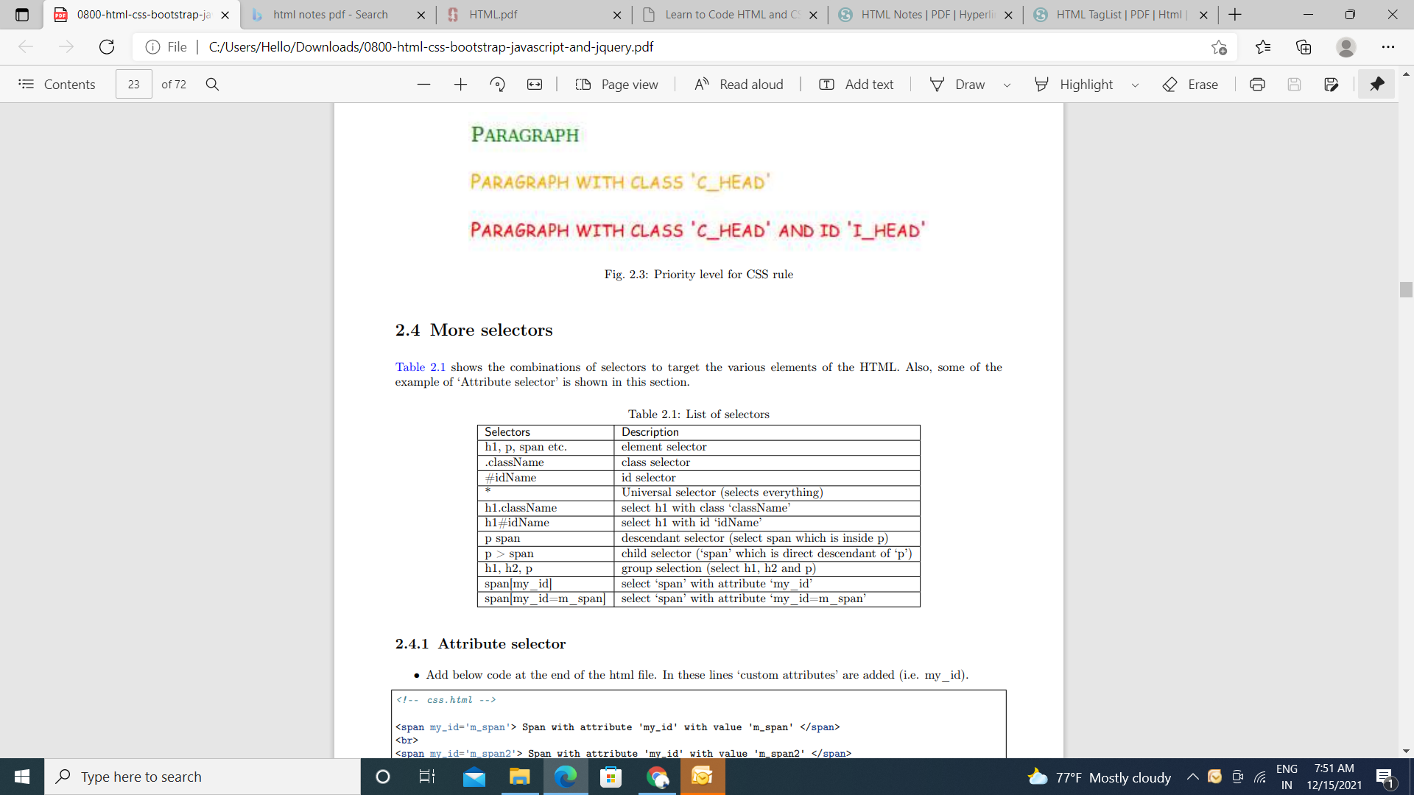

**More selector :**

Below table shows the combinations of selectors to target the various elements of the HTML. Also, some examples of ‘Attribute selector’ are shown in this section.



Attribute selector :

• Add below code at the end of the html file. In these lines ‘custom attributes’ are added (i.e. my_id).

<span my_id='m_span’> Span with attribute 'my_id' with value 'm_span’ </span>

<br>

<span my_id='m_span’>Span with attribute 'my_id' with value 'm_span2' </span>

• These custom attributes can be selected as below,

/*attribute selection*/

Span[my_id] { /* select 'span' with attribute 'my_id' */

color: green;

font-weight: bold

}

span[my_id=m_span] { /* select 'span' with attribute 'my_id = m_span' */

color: red;

}

**More properties :**

Table shows the some more important properties which can be used in CSS

